**TASK 1**

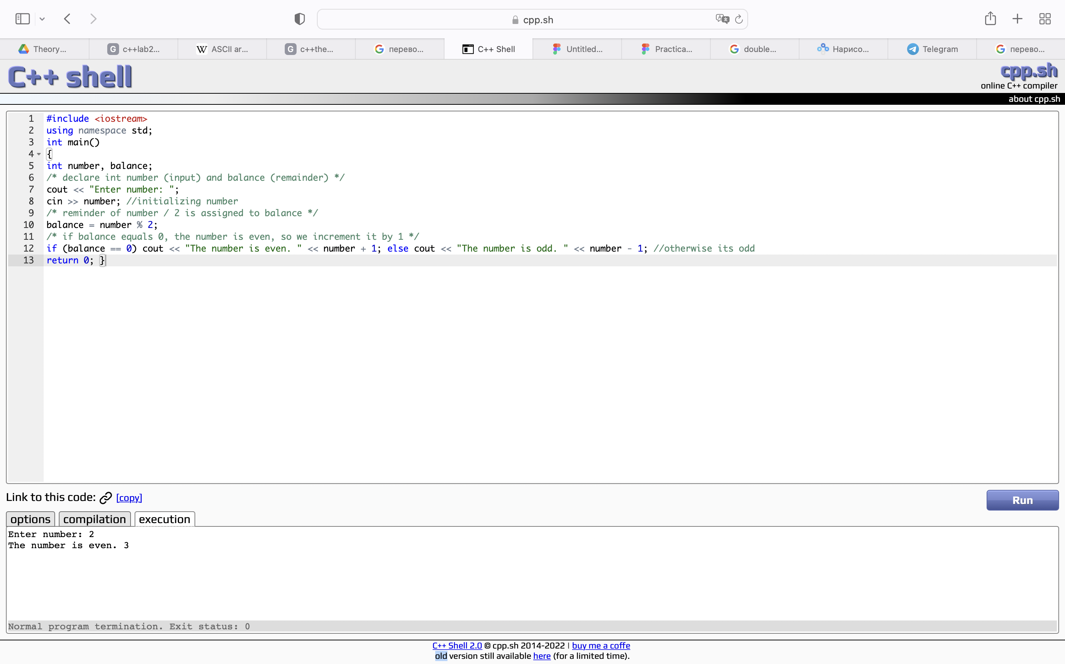

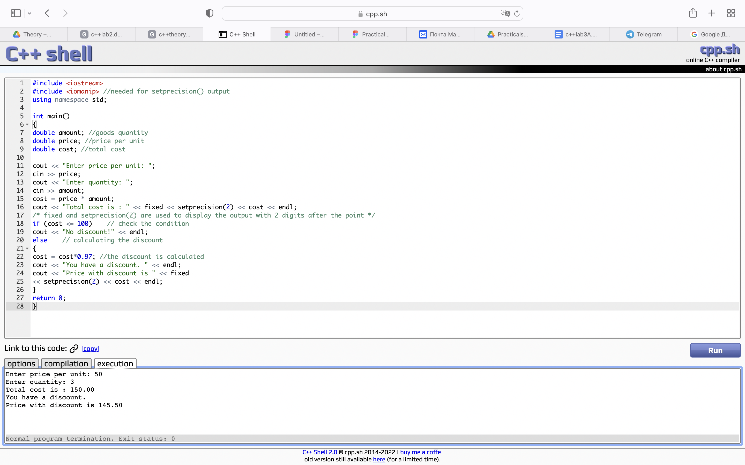**TASK 2**

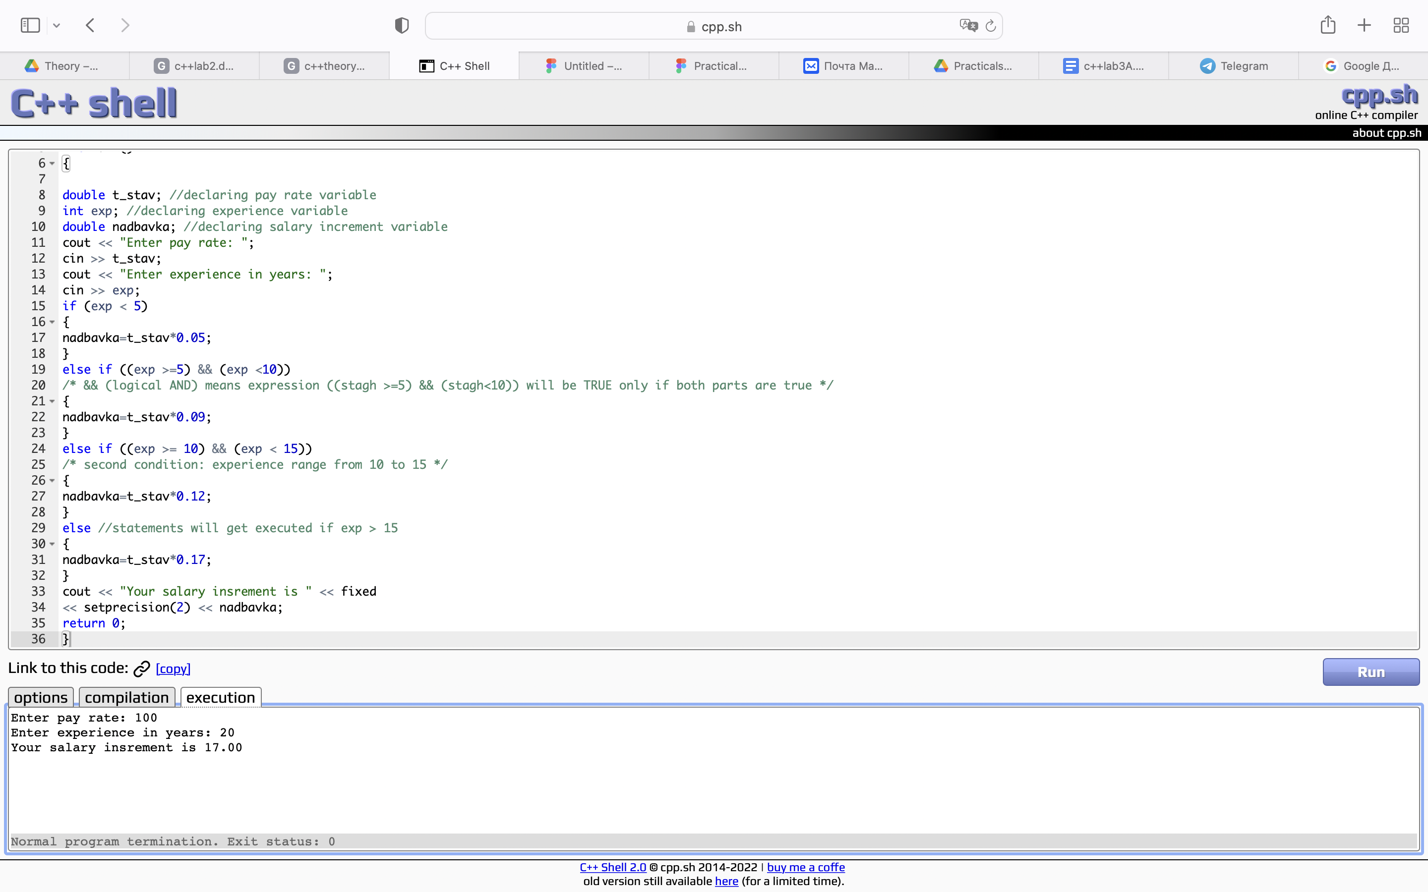**TASK 3**

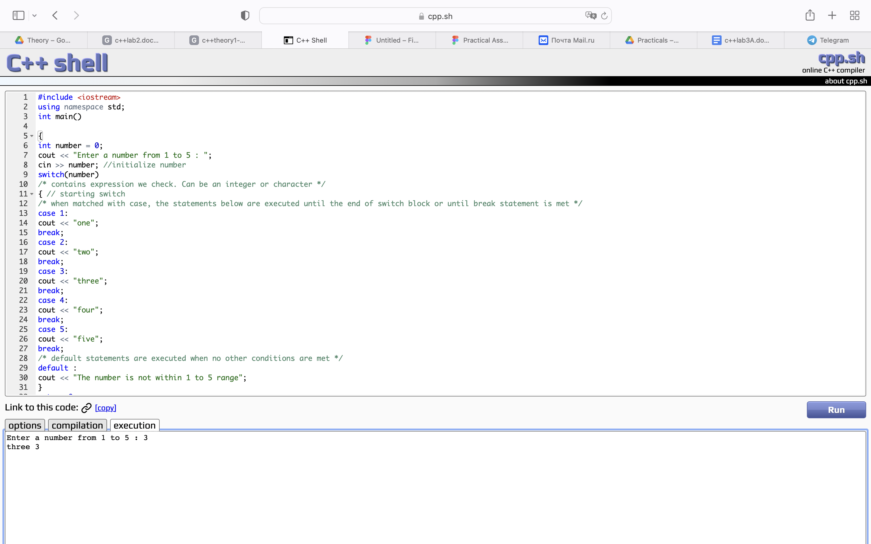**TASK 4**

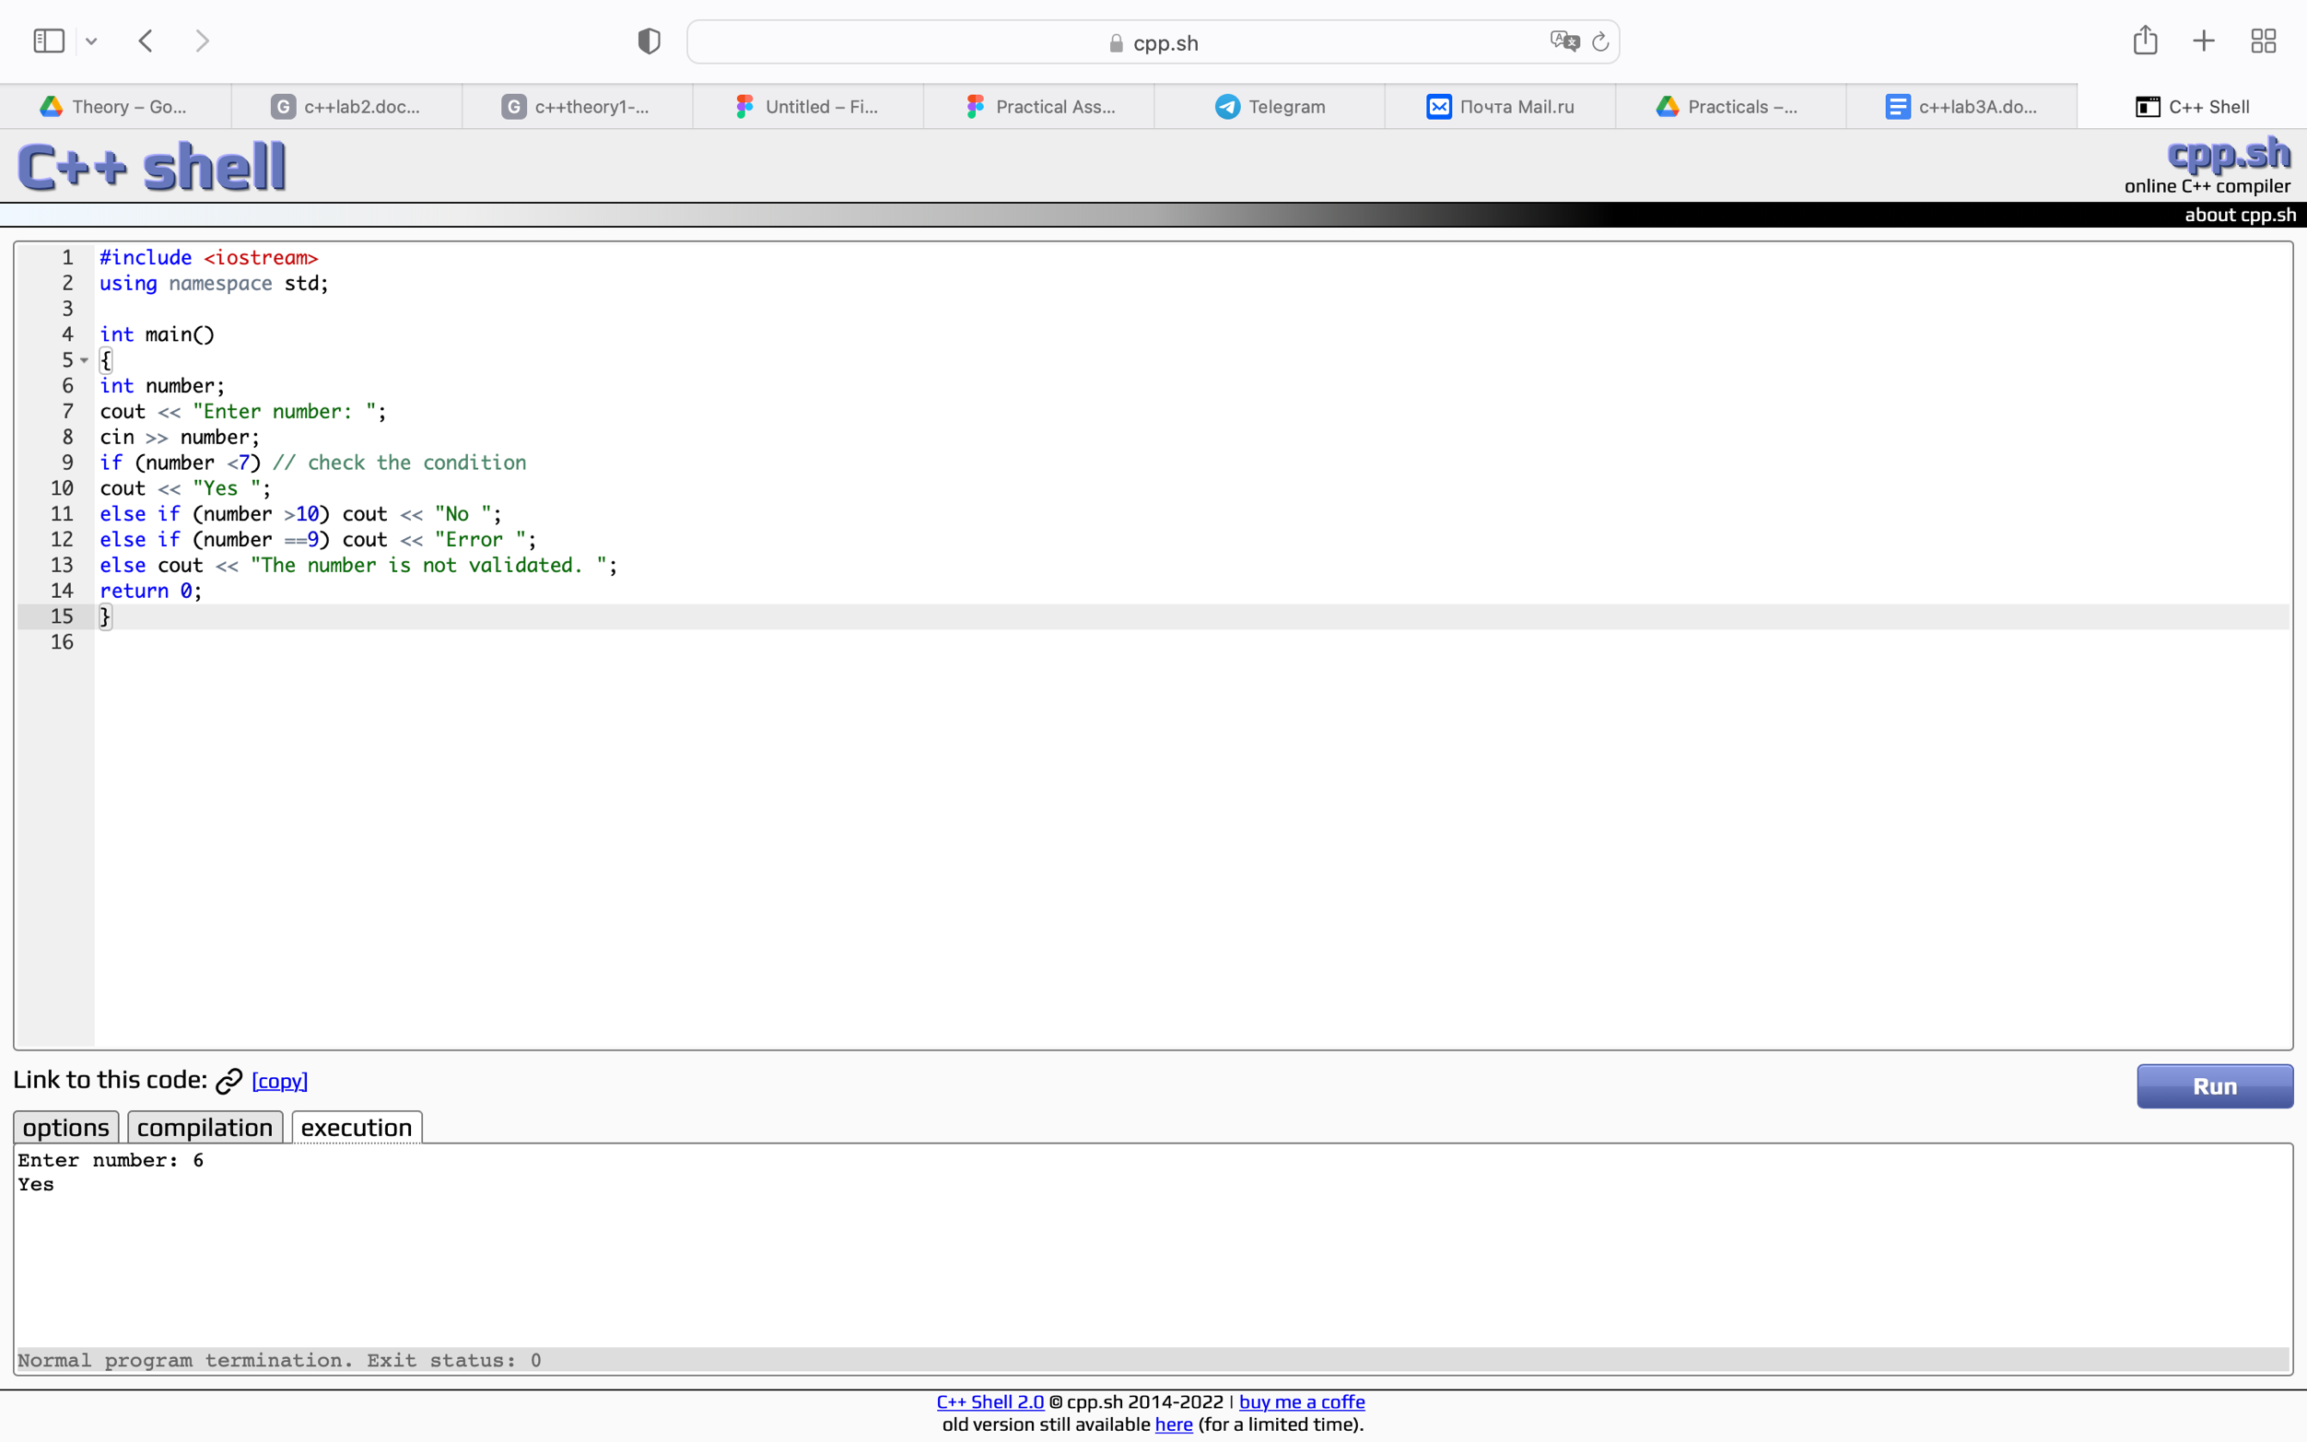**TASK 5. 1**

#include <iostream>

using namespace std;

int main()

{

int number;

cout << "Enter number: ";

cin >> number;

if (number <7) // check the condition

cout << "Yes ";

else if (number >10) cout << "No ";

else if (number ==9) cout << "Error ";

else cout << "The number is not validated. ";

return 0;

}

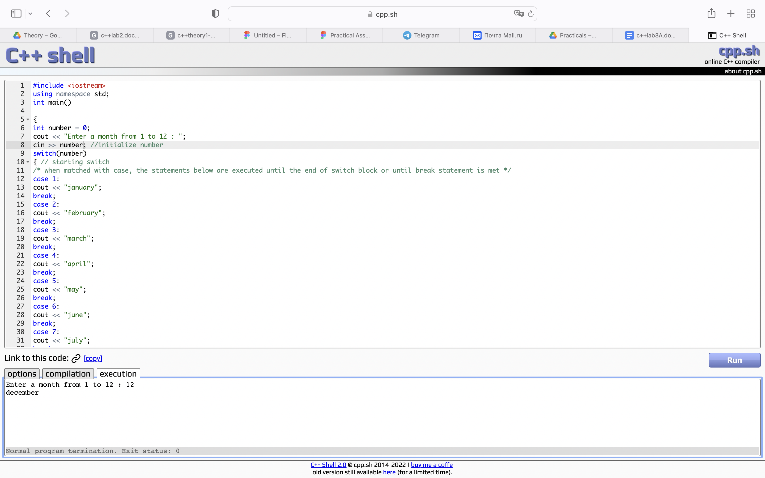**TASK 5.2**

#include <iostream>

using namespace std;

int main()

{

int number = 0;

cout << "Enter a month from 1 to 12 : ";

cin >> number; //initialize number

switch(number)

{ // starting switch

/* when matched with case, the statements below are executed until the end of switch block or until break statement is met */

case 1:

cout << "january";

break;

case 2:

cout << "february";

break;

case 3:

cout << "march";

break;

case 4:

cout << "april";

break;

case 5:

cout << "may";

break;

case 6:

cout << "june";

break;

case 7:

cout << "july";

break;

case 8:

cout << "august";

break;

case 9:

cout << "september";

break;

case 10:

cout << "october";

break;

case 11:

cout << "november";

break;

case 12:

cout << "december";

break;

/* default statements are executed when no other conditions are met */

default :

cout << "The number is not within 1 to 12 range";

}

return 0;

}

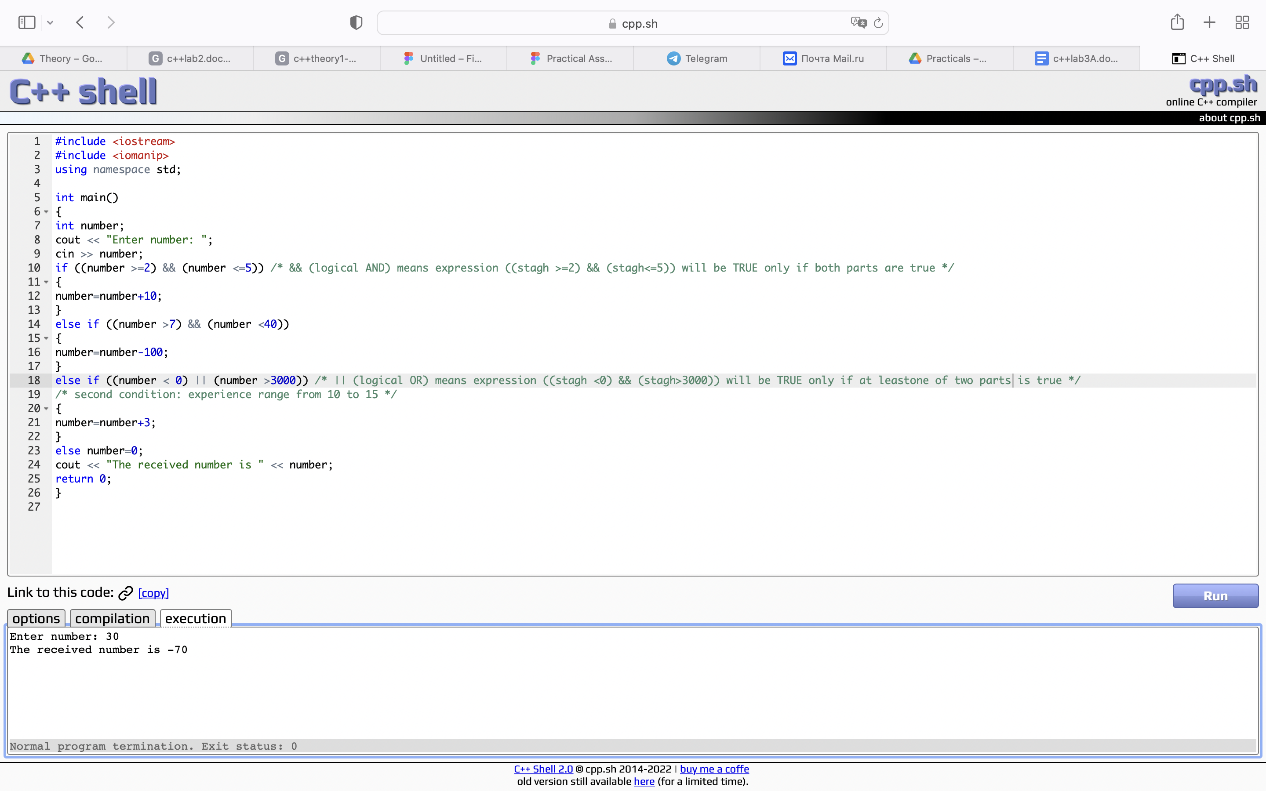**TASK 5.3**

#include <iostream>

#include <iomanip>

using namespace std;

int main()

{

int number;

cout << "Enter number: ";

cin >> number;

if ((number >=2) && (number <=5)) /* && (logical AND) means expression ((stagh >=2) && (stagh<=5)) will be TRUE only if both parts are true */

{

number=number+10;

}

else if ((number >7) && (number <40))

{

number=number-100;

}

else if ((number < 0) || (number >3000)) /* || (logical OR) means expression ((stagh <0) && (stagh>3000)) will be TRUE only if at leastone of two parts is true */

/* second condition: experience range from 10 to 15 */

{

number=number+3;

}

else number=0;

cout << "The received number is " << number;

return 0;

}